Activity: What Can You See?

Introduction

Weather satellites have sensors aboard that detect both visible light and infrared or heat radiation. The sensors providing views of reflected sunlight are engineered to be more detailed than infrared, so that smaller objects can be seen. However, visible images are only available during the day, limiting their continuous monitoring of weather conditions. Although less detailed, infrared views are temperature maps of surfaces viewed from the satellite’s vantage point, whether land, water or clouds. The temperature variations of the surfaces may be enhanced to highlight certain features of interest to meteorologists.

After completing this activity, you should be able to:

- Explain how satellite pictures can be made with reflected sunlight (visible radiation) and with the heat (infrared radiation) given off by Earth.

- Describe the advantages and disadvantages of visible-light weather satellite pictures.

- Describe the advantages and disadvantages of infrared-radiation weather satellite pictures.

Method

The accompanying drawing shows an Earth surface and atmospheric cross- section. A temperature scale at the left shows the decrease in temperature with an increase in height in the atmosphere.

The numbers in the drawing indicate temperatures of various surfaces. For example, the lake surface is at +23 degrees C, the upper surface of the fog bank is +18 degrees, and the thunderstorm top is at a very cold –64 degrees.

The rates of infrared (heat) radiation from objects are related to their surface temperatures. The higher the surface temperature, the greater the radiation. The lower the temperature, the less the radiation. Because of this, the cold tops of high clouds appear white while the tops of warmer low clouds appear gray in infrared pictures (unless the images have been enhanced). Land and water surfaces being the warmest often appear darkest.

©American Meteorological Society

Questions

- What does a satellite “see” when it senses the Earth in reflected sunlight (visible radiation)? Imagine yourself looking straight down from a satellite moving across the top of the drawing. Your direction of travel is shown by the arrow. List the sequence of things you would see as you make the trip across the field of view.

Could you see this same scene at night?
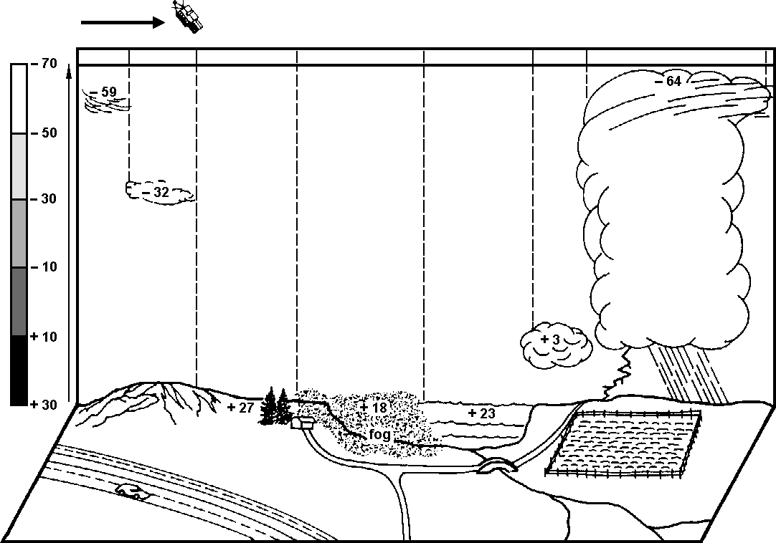

- What does a satellite “see” when it senses the Earth by infrared radiation? Imagine yourself making the same scan but now you sense the heat or infrared radiation given off by the upper surfaces of objects. Using the shading scale for temperature at the left as a guide, shade in the strip along the top of the picture based on the temperatures of surfaces directly below. List the sequence of “things” (shadings) you would see as you scan across the field of view.

Could you see as many different things as you saw with visible light? Can you distinguish between land, fog, and water?
Were there some things you could “see” better in the infrared scan than in the visible light view?

Which are whiter in shading, low or high cloud surfaces? Can you see this temperature scene day or night?
- In the list below, place a (✓) in the appropriate column to indicate which kind of satellite view (visible or infrared) is better suited to provide the information requested:

 | Visible | Infrared
a. 24-hour coverage of atmosphere
b. finer details of cloud surfaces
c. temperatures of cloud tops
(and indirectly, their heights)
d. distinguishing fog from surrounding Earth surfaces
e. determining extent of snow cover on ground
f. detecting small fair-weather clouds
g. the color-coding of cloud tops

Real World Applications
Figure 3 on the following page shows three satellite images sensed at the same time, 1815Z or UTC (2:15 pm EDT) on 26 August 2011. At that time generally fair weather was experienced by most of the coterminous U.S. A cold front was advancing southeastward from Canada into the north-central U.S. The major feature seen in the images was Hurricane Irene located off the Georgia and South Carolina coast heading northward. Irene made landfall the following morning on North Carolina’s Outer Banks as a Category 1 hurricane on the Saffir-Simpson scale.

The top visible image in Figure 3 shows the small fair-weather cumulus clouds in a broad band from New York State to the Texas Gulf Coast and northern Mexico. Small cumulus clouds are also seen over the Rocky Mountains in the western states. The broad curving band of cumulus and higher cirrus clouds forming an arc from north of Lake Superior to southern Nebraska marked the region ahead of the advancing cold front. A deck of stratus clouds hugs the West Coast from Oregon to Baja California of Mexico. A couple of thunderstorms can be seen as bright white dots with wispy cirrus blowing off their tops in the Gulf of Mexico west of Florida.

The left infrared image display the coldest cloud surfaces as bright white shadings. These cold cloud tops are typically associated with thunderstorms as make up Hurricane Irene, the Gulf dots and the band of the cold front over Lake Superior and in Iowa. Lower clouds are located where the atmosphere is warmer and appear darker gray in shading. They can be seen over the southwestern mountains, in northern Mexico, and off the southern California coast. The lowest and warmest clouds are dark gray and close to the shade of the land surfaces whose temperatures they are near. The cumulus band from New York to Texas and the stratus deck along the West Coast.

The right water vapor image shows the concentrations of water vapor in the middle troposphere, typically between 13,000 and 30,000 feet (4000 to 9000 meters). Bright white shades are high cloud tops as seen with Hurricane Irene and along the cold frontal band. Middle gray shades are relatively large water vapor concentrations in the middle atmosphere, but perhaps without clouds present. Dark gray or black shades are relatively dry layers. One can see the high water vapor concentrations across the Gulf of Mexico and northern Mexico. There is also a plume or “river” of vapor arcing over the southwest U.S. and above the cold frontal location of ground level. From central Texas to the Northeast, relatively dry air exists. Shading waves over the Northwest show how water vapor images display atmospheric motions that are evident in animations.

- In visible satellite images, all clouds [(are)(are not)] seen as generally equally white.

- Small fair-weather cumulus clouds appearing in visible satellite images
[(are)(are not)] readily visible in infrared or water vapor images.

- Low clouds along the West Coast seen in visible images [(are)(are not)]
readily seen in infrared images.

- Visible and infrared images [(do)(do not)] detect the broad flows of water vapor in the atmosphere over the western and north-central U.S.

- Being sensitive to the high, thin, cold cloud tops (infrared image) and the upper atmospheric water vapor (water vapor image) of Hurricane Irene, the extent of the hurricane structure is [(more)(less)] expansive than seen by the visible image.

- The visible image shows that there was no significant cloud cover over the northwestern portion of Mexico. The darkness of shadings in the infrared image of the Baja California peninsula of Mexico and the Gulf of California to its east shows that, at the time of the satellite views, the land surface of Baja was [(cooler)(warmer)] than the water surface of the Gulf.

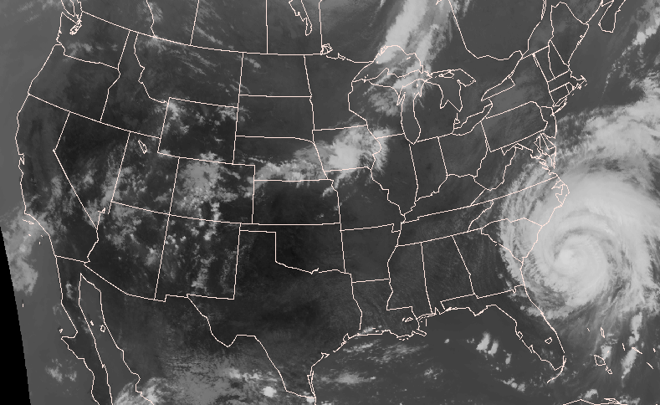
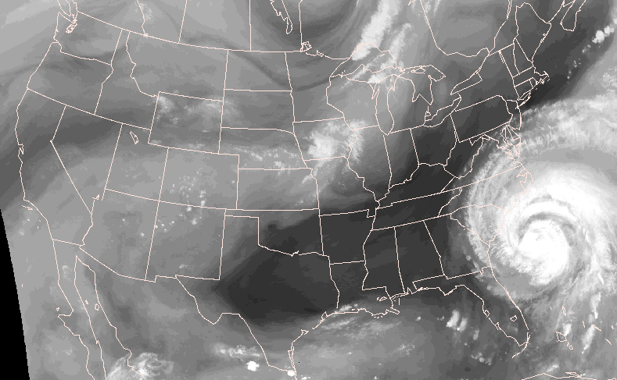
Types of Satellite Images
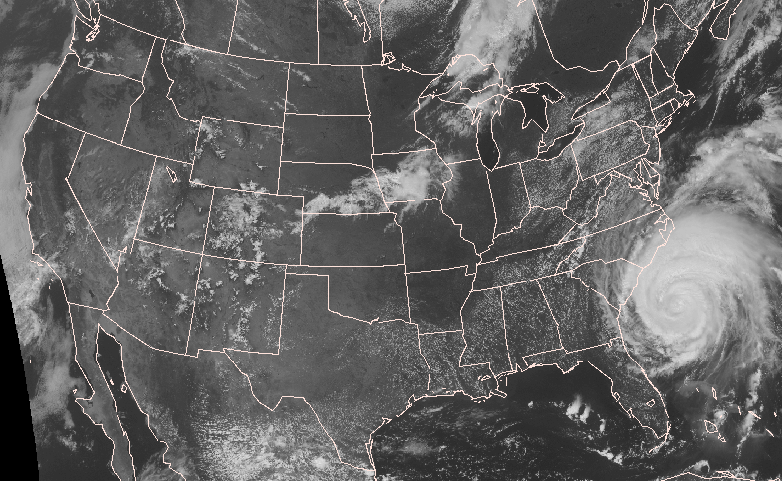
Figure 3. Visible satellite image at 1815 UTC, 26 AUG 2011.

Infrared satellite image at 1815 UTC 26 AUG 2011. Water vapor satellite image at 1815 UTC 26 AUG 2011.

